Week 3 Lab Task
Scanning & Enumeration
NIAI NAVTTC — Certified Ethical Hacker (CEH) Course
⚠ Important: All tasks must be performed only in your isolated virtual lab environment. Never test on real networks or systems without explicit written permission.
▶ Write a Scan Report
Record the following for each host found:
- IP address and hostname
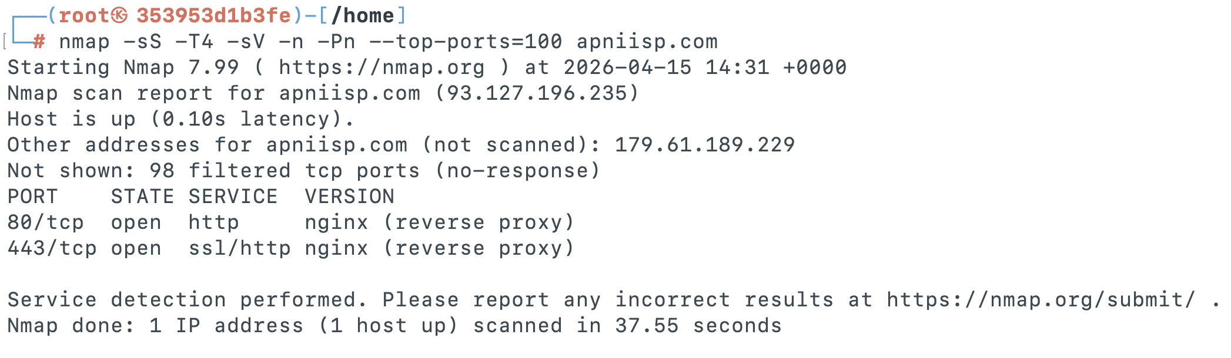
- Open ports and services running

- Operating system detected
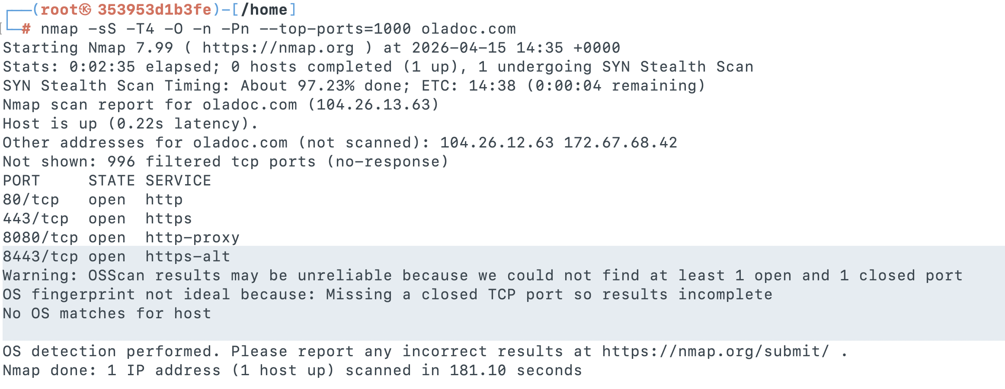

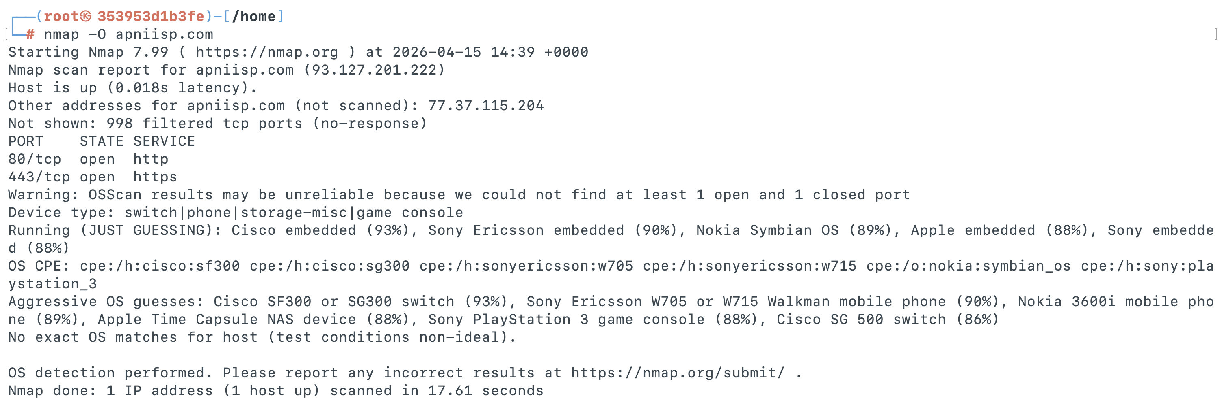
- Any vulnerabilities flagged by Nmap
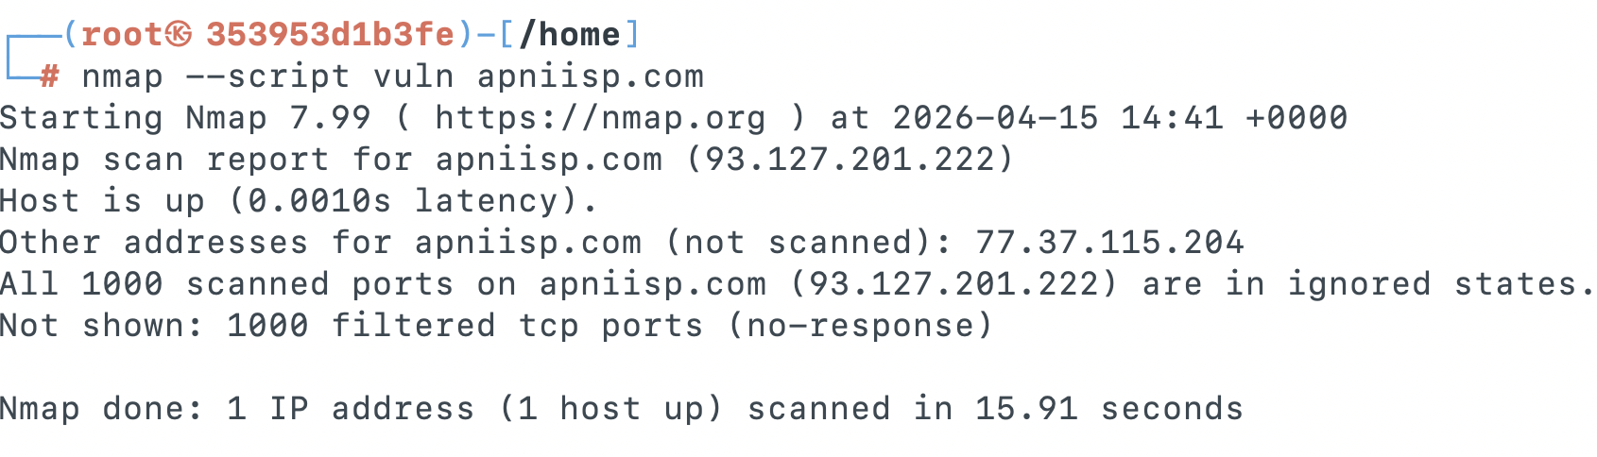

- Any users/shares found during enumeration
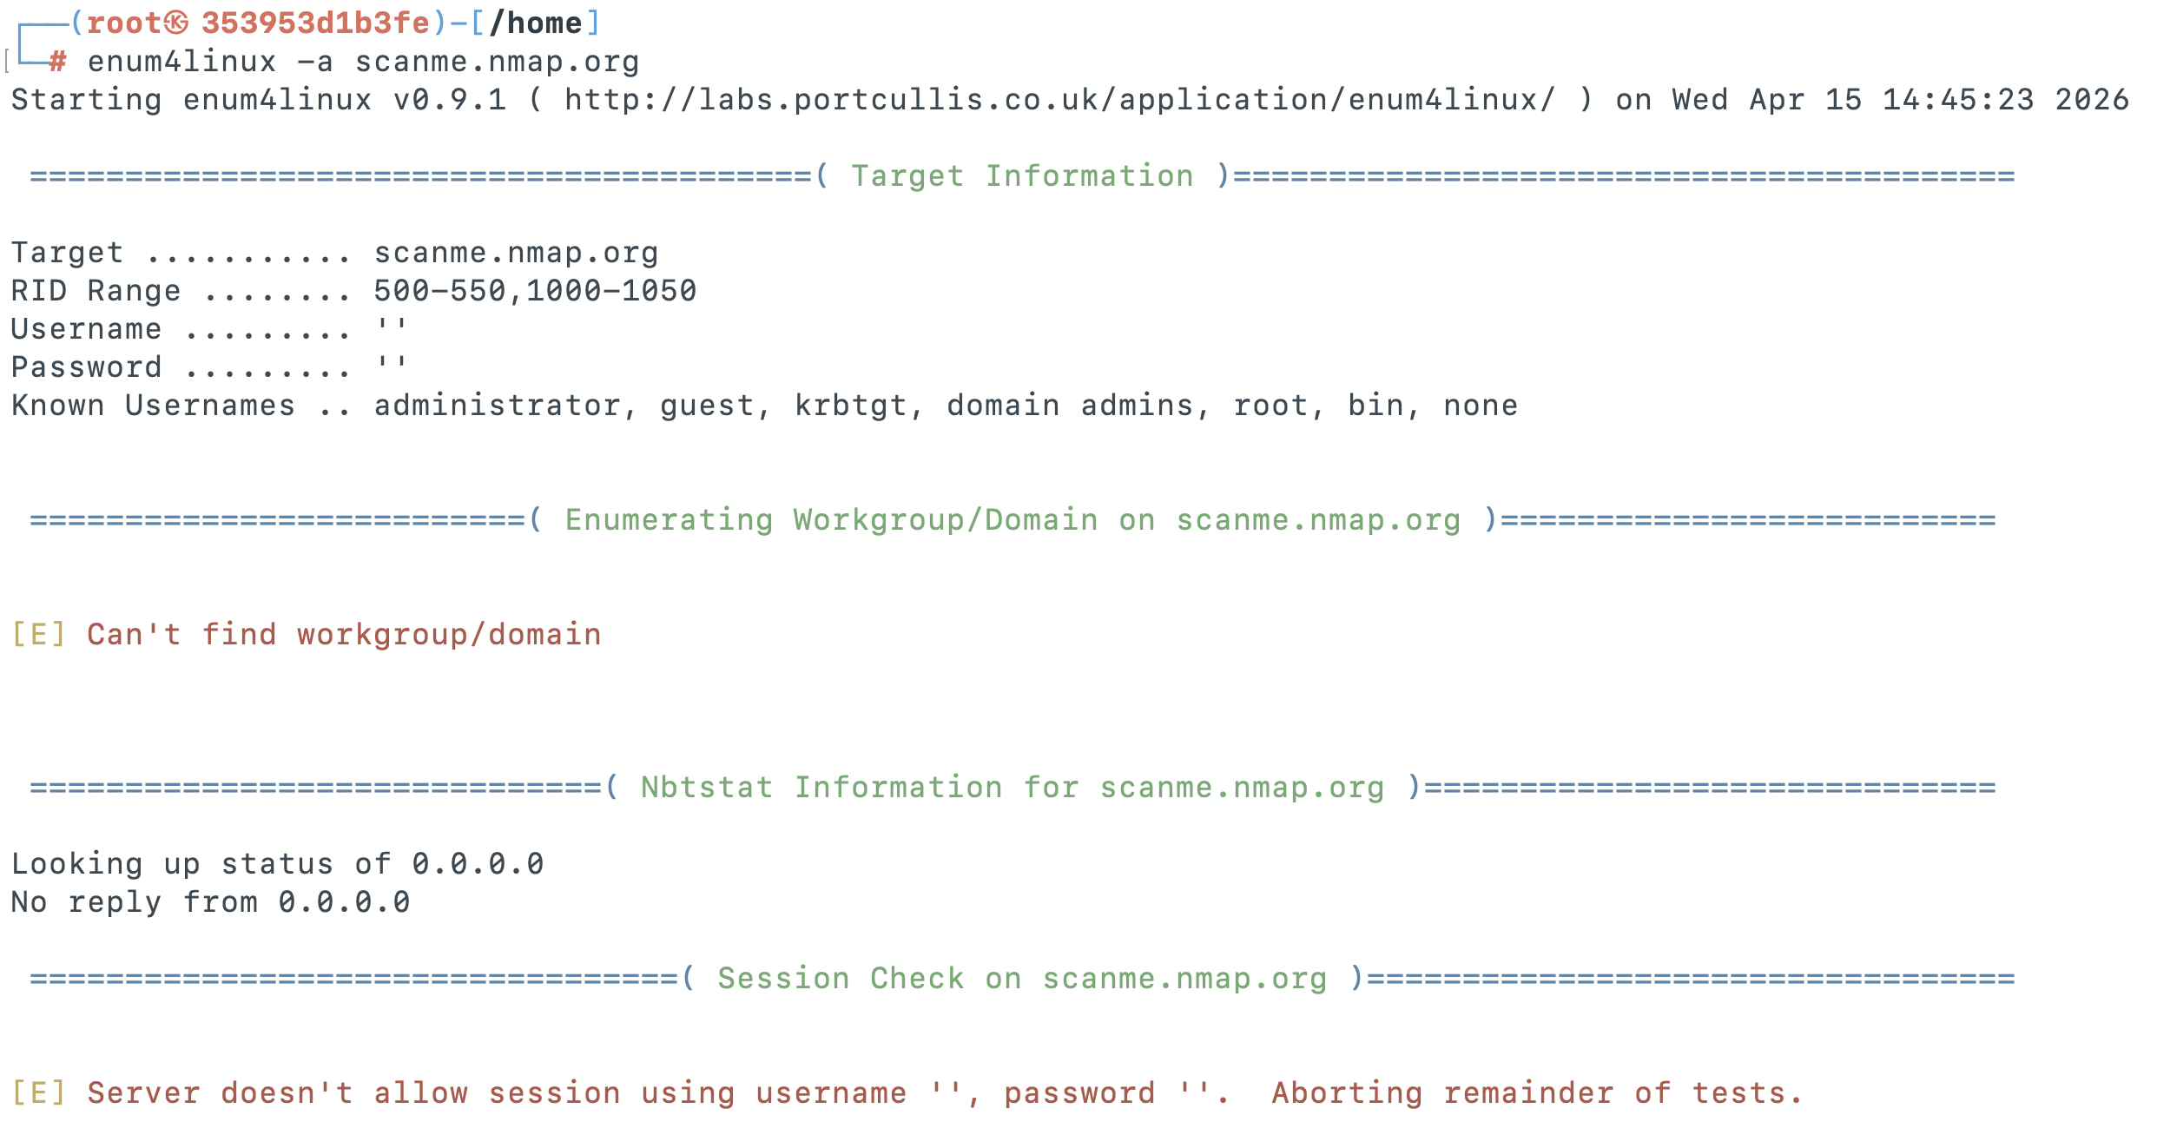
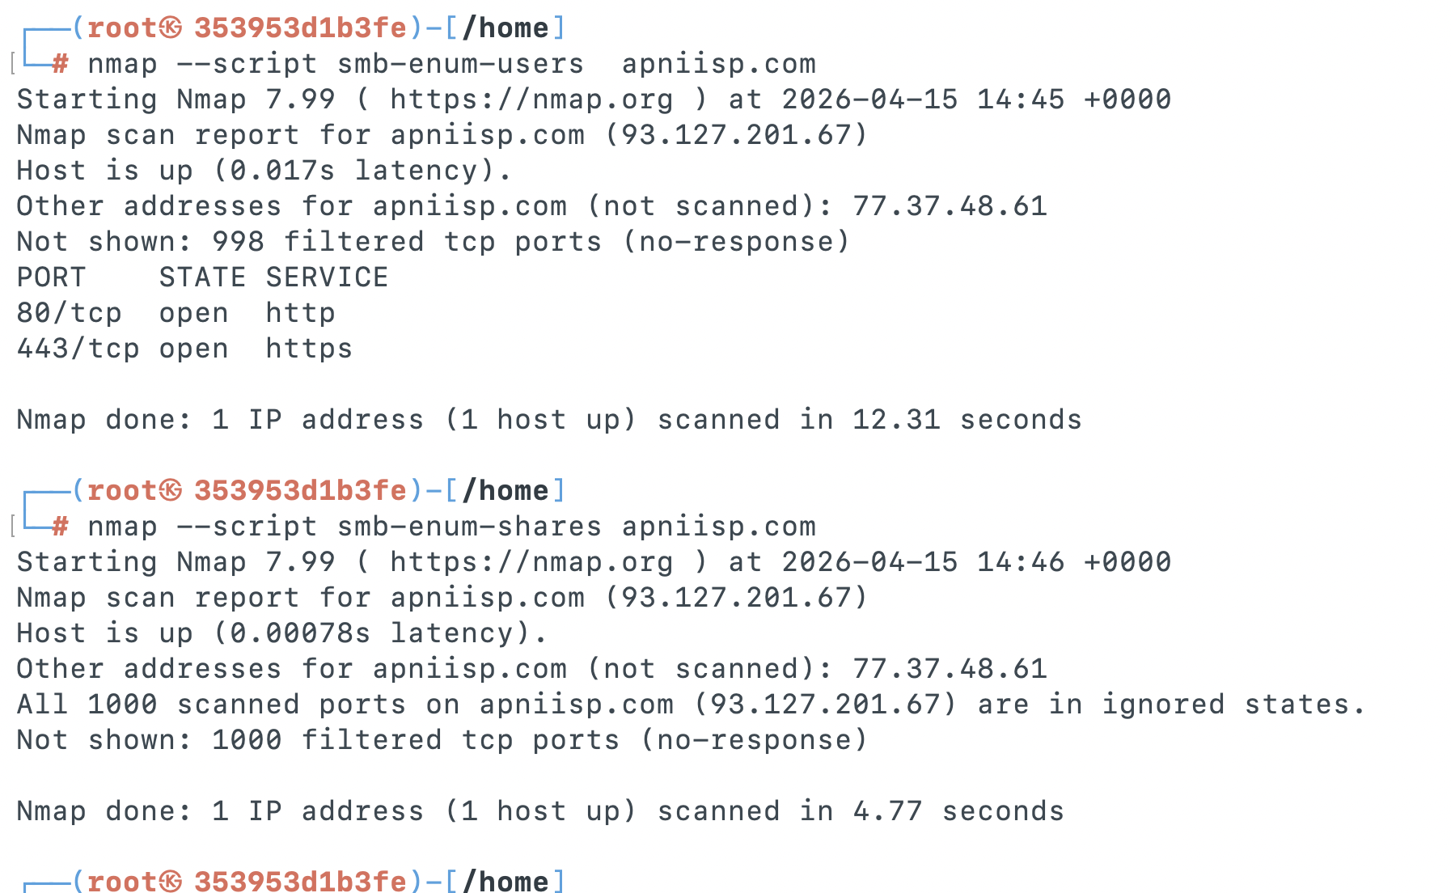
🎯 Goal: A complete scan report listing active hosts, open ports, running services, OS info, and enumerated users/shares — with potential vulnerabilities identified.

